BIO520 Bioinformatics Spring 2007 Name:
EXAM2

You may use any books, notes, web pages, software programs, or related materials to complete this exam. You MAY NOT consult with any person regarding the exam’s intellectual content.
Please email this lab to Lin Xue at both the email addresses:
lxue2@uky.edu
lionetlinxue@gmail.com
1. (5 pts) Match each left column database/program with a single application in the right column. There are extra entries in the right column. Inidcate your answer as (A8, B10, C4, etc).

A. Ensemble
B. PHRED/PHRAP
C. MFOLD
D. PSORT
E. TRANSFAC
F. VectorNTI
G. MMDB
H. GENSCAN
I. PHYLIP
J. PDB

1. Protein threading.
2.Manipulate sequences and formats, annotate seqeunces.
3. Transcription factor binding sites.
4. Protein subcellular location.
5. DNA sequencing and assembly.
6.Protein structure database.
7. Phylogenetics trees construction and analysis.
8. Genome database.
9. De novo gene finding.
10. Protein structure viewer
11. RNA folding.
12. NCBI protein structure database.
13.RNA structure database.

2. Examine the Genscan gene predictions for a C. familiaris genomic sequence.
a. (3 pts) For each predicted gene, give the number of exons and the strand.

b. (1pt) Does Genscan rate these predictions as high or low confidence?

c. (2 pts) These predictions correspond poorly to the NCBI genome annotation made with GNOMON. What other criteria/methods (other than de novo gene prediction) are/can be used be GNOMON to improve gene and exon prediction?

3. Examine PDB entry 1ICI either using the linked PDB file or PDB web entry.
a. (2 pt) How was this structure determined and what is the resolution of this structure? (answer must include resolution and the units it is measured in)

b. (1 pt) Other than protein and water, what other molecules are present in this structure?

c. (1 pt) This structure has an R-value of 0.2. What is the R-value?

d. (1 pt) What is the approximate physical size of one subunit of this protein?

4. RNA secondary structure.
a. (1pt) Is the hairpin loop a, b, c, or d in the figure below?

b. (1 pt) What is the role of helical stacking on RNA structure?

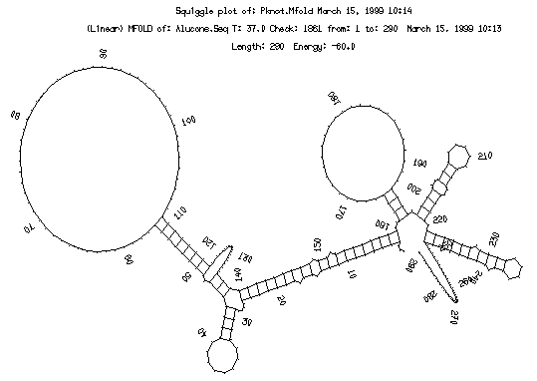
c.
a.
b.
d.

5. (2 pts) In determining the structure of protein using computational methods indicate the type of method appropriate with the circumstance.
Methods: A. Homology modeling, B. Threading, C. Ab initio structure prediction, D. No method likely to work.
1. Protein with 80% identity to a protein with an experimentally determined structure.
2. Protein with no BLAST match to any protein with an experimentally determined structure.
3. Predicted membrane protein, 668 aa, threading fails to find any structure candidates.

6. (2 pts) Given a protein with homology only to other proteins of undertermined function, describe steps you could take to characterize it computationally. Give two things you attempt to predict about it and the program/analysis you would use.

7. You wish to construct a phylogenetic tree based on sequences from an enzyme in the CoQ synthesis pathway. The sequences (organism indicated) you have chosen to use are shown below.

These are the sequences:
COQ7_Homo_sapiens
CLK-1_Gallus_gallus
IMAGE_7024122_Xenopus_tropicalis
dclk-1_Caenorhabditis_elegans
AN4569.2_Schizosaccharomyces pombe

7a. (1 pt) Which sequence would be the best choice for rooting the phylogenetic tree?

7b. (1 pt) If after bostrap analysis a node on the tree has a score of 53%, would you consider the subtree under that node to reliable?

7c. (2 pts) What factor would have the greatest impact on the number of computations needed to complete a bootstrap analysis on a phylogenetic tree constructed using a character-based method such as maximum likelihood: doubling the number of sequences or doubling the length of an alignment? Why?

8. (3 pts) You construct a phylogenetic tree of 10 insect species from rRNA sequences using maximum parsimony while another graduate student in your lab uses the same sequences and the UPGMA method. Your trees differ. How can you resolve this problem and find a tree in which you are confident?

9a. (1pt) In the cladogram below which taxa are in the monophyletic clade including taxa A and D (i.e., A-D-F)?

,-------------------------------- A
|
| ,------ B
| ,----|
-----| | `------ C
| ,------------------|
| | `----------- D
`--|
| ,--- E
`--------------------------|
| ,- F
`-|
`- G

9. The dog genome has been sequenced to 7.6X using WGS.
a. (2 pts) What deficiencies would you expect in an assembly of this sequence?

b. (3 pts) You have been funded to finish the dog genome sequence. Outline a three point plan to accomplish this.
1.

2.

3.

10. (2 pts) In the chimpanzee genome paper was assembled using two different programs. What are these two programs, what is the main difference between their genome assembly algorithms?

